Report for UI Automation using Robot framework=Success

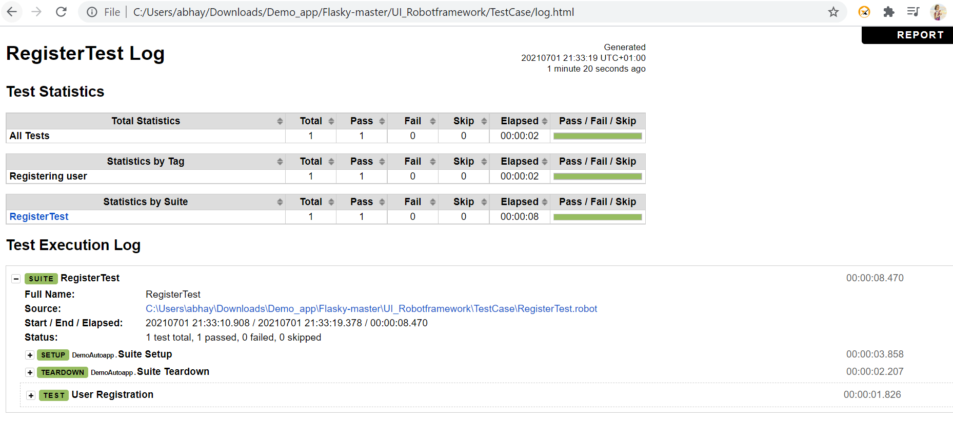

Report for API Automation Using Python

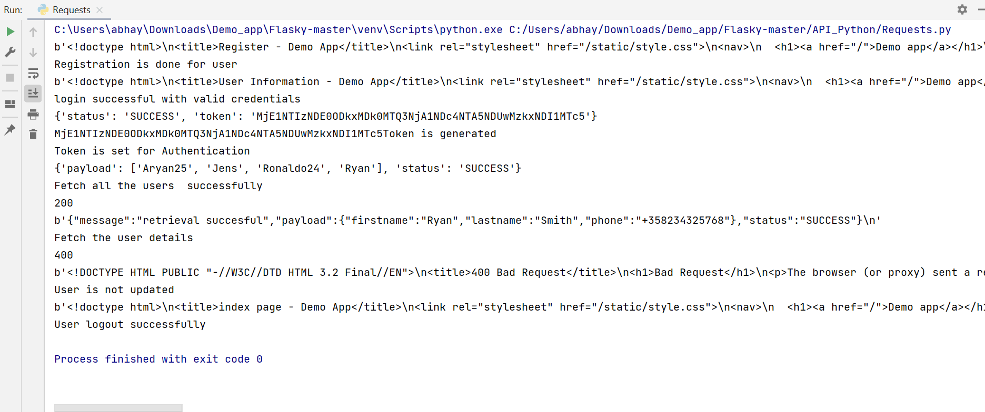

Note- After token is generated and accepted. GET user details is working. but updating the user with PUT request not showing results.